Written Assignment Unit 1
- Find the domain of the function $f\left(x\right)=\frac{\sqrt{x-6}}{\sqrt{x-4}}$ using interval notation.
Solution
Since both the numerator and denominator are under the even root, there is a need to we exclude any real numbers that result in a negative number in the radicand by setting the radicand greater than or equal to zero and solve for x.
Numerator: $x-6≥0$, which leads to $x≥6$
Denominator: $x-4≥0$, which leads to $x≥4$
Domain of the function is $\left(-∞,4\right]U[6 ,∞)$
- Sketch a graph of a piecewise function. Write the domain in interval notation.
$y=x^{2}$for $\{-1≤x≤1\}$ and $y=3x-2$ for $\{1≤x≤3\}$
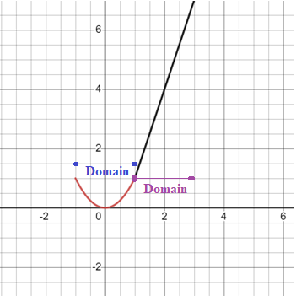 Domain: $[-1,1] U [1,3]$
3. The cost in dollars of making x items is given by the function $C(x) = 10x + 500$.
a) The fixed cost is determined when zero items are produced. Find the fixed cost for this item.
$C(0) = 10(0) + 500=\$500$
b) What is the cost of making 25 items?
$C(25) = 10(25) + 500=\$750$
c) Suppose the maximum cost allowed is $1500. What are the domain and range of the cost function, C(x)?
The domain of the cost function $C(x) = 10x + 500$ is all non-negative real numbers since it is impossible to have number of items with negative values. The same will apply to the range since the cost can also not be negative values. Therefore, the domain and range of the function are both $[0, ∞)$ in interval notation.

